**Boat Wash App Enhancment**

**Business Requirements Document**

**Ver 2.0**



|  |  |  |  |
| --- | --- | --- | --- |
|  | Prepared By / Last Updated By | Reviewed by | Approved By |
| Name | Ahron |  | ATPL |
| Role | Project Manager |  |  |
| Signature |  |  |  |
| Date | Feb 10th , 2022 |  |  |

Table of Contents

1.0 Introduction 3

1.1 Purpose of this document 3

1.2 Project Overview 3

1.3 Scope 3

1.3.1 In Scope 3

1.3.2 Out of Scope 3

1.4 Intended Audience 4

1.5 Constraints, Assumptions, and Dependencies 4

2.0 Organization Architecture 5

2.1 Boat wash application team 5

2.2 Augurs Technology Pvt. Ltd. 5

3.0 Business Process Analysis 6

3.1 Current Scenario 6

3.2 Workflow 6

3.3 Admin Panel Enhancements 10

3.4 Detailed Business requirements (Android) 12

3.5 Detailed Business requirements (ios) 13

3.6 Detailed Business Requirement (Admin Panel) 14

4.0 Technical specifications 15

5.0 References 15

6.0 Change Log 15

# Introduction

## Purpose of this document

This document is aimed at:

* Providing the necessary inputs to the detailed requirements gathering phase and further on for the SDLC processes.
* This document also serves to establish the traceability between the Business Objectives and the requirements identified in the proposed solution and how they satisfy the stated objectives.
* Provide expectation traceability in terms of the requirements and the user expectation
* Serves as a formal template for documenting the Business Requirements which also includes statutory and regulatory requirements.

## Project Overview

To make certain changes and updates few new features within the existing app named – “Boat Wash”. And admin section of the application.

## Scope

### In Scope

1. Boat wash booking from the wash centers
2. Option for the users to choose the pass
3. Choose available slot for the current month for booking for your boat wash on the basis of the offers shown on the pass.
4. Pay now
5. Booking confirmation
6. QR code generation (user will go and show that QR code to the wash center for their boat wash)
7. Admin panel for adding different boat wash centers and manage booking like – booked slots and available slots etc.

### Out of Scope

* Any additional task which is not included in this scope document
* 3rd party tools integrations or functionality which is not discussed or captured in this document.
* Any unidentified dependent development activity, get identified during the development phase

## Intended Audience

* Boat wash management team
* Graphic /web UI designer
* Development team
* Augurs Team - Project management group, Delivery Assurance Group & QA group

## Constraints, Assumptions, and Dependencies

Once identified, these assumptions and constraints shape a project in specific, but diverging ways – assumptions bring possibilities, whereas constraints bring limits.

At a minimum, as the project begins, assumptions and constraints must be defined for one or more of the following elements:

* Key project member’s availability
* Key project member’s performance
* Key project member’s skills
* Internal process lead time
* Vendor delivery times
* Vendor performance issues
* Accuracy of the project schedule dates

Project limitations typically fall into several categories.

Our project’s drivers and supporters may have preset expectations or requirements in one or more of the following categories:

**Results:** The products and effects of your project. For example, the new product must cost no more than $300 per item to manufacture, or the new book must be fewer than 384 pages in length.

**Time frames:** there may have a few tasks where the planned timeline may differ from the actual timeline due to the complexity of the hidden scope.

**Resources:** The type, amount, and availability of resources to perform your project work. Resources can include people, funds, equipment, raw materials, facilities, information, and so on.

**Assumptions:**

* The client will provide all content and timely and approvals
* Assuming the details shared by the client are in the scope of development.

**Constraints:**

* Perfectly execution of the Boat wash app infrastructure
* Quality of the features shown on the Boat wash app

**Dependencies:**

* Discussions with the client to understand the core business activities to convert to business logic and its requirements

# Organization Architecture

## Boat wash application team

*Details to be provided by the client

|  |  |  |  |
| --- | --- | --- | --- |
| Name & Position | Primary Responsibilities  (relative to project) | Module | Primary Responsibilities  (relative to application business process) |
|  |  |  |  |
|  |  |  |  |
|  |  |  |  |

## 

## Augurs Technology Pvt. Ltd.

|  |  |  |
| --- | --- | --- |
| **Name & Position** | **Primary Responsibilities (relative to project)** | **Primary Responsibilities**  **(relative to application business process)** |
| Ana(Business Analyst) | Overall project management both from  Client-end and development team. | Managing complete project. Responsible for solving any concern of the client, team. |
| Ahron (Project Manager) | Overall Project  management and its closure | Managing the whole project from the scratch |
| Development team | Responsible for the development of the  Complete Boat Wash application | Collect and understand the initial requirement of the application and work accordingly. |

# Business Process Analysis

## Current Scenario

To develop an app named – “Boat Wash”. The application will be helpful for the users who has their boats and want to wash them at the nearest service wash center. The application will be helpful for the users in various aspects in terms of the Quality of the washing and payment prospect and on time delivery of the boat after washing.

**Note: All the contents would be in Swedish language**

## Workflow

Once the user will open the application he/she will be able to navigate the app below is the flow that will be implemented within the application

* **Changes in the footer section of the current app:** We need to replace profile icon with setting button and one new screen will be added for all the booking made by the user**.** When user will click on the booking icon at the bottom then the list of all the bookings will be appeared which will contain the info like- Sr no, wash centre name, amount paid, date and time of booking
* **Select Washing centre:** User will have the list of all the washing centres which will be coming from the admin panel.Refer below **Figure 1** which will have all the wash centres available for the users for washing their boat

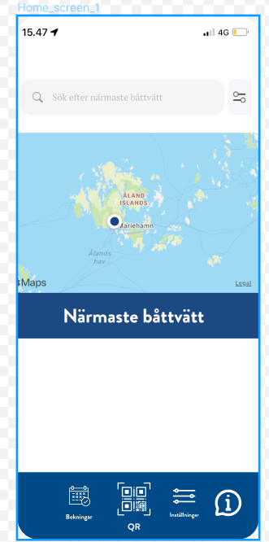

**Figure 1**

* **Booking Screen (New option for choosing pass):** User will have the feature within the application for booking the session for their boats to wash from the particular wash centres which user have selected, Following below information will be displayed. Refer the below

**Figure 2** for the reference

* Booking pass – User will click on the booking pass which will be added new on the existing booking screen
* Select washing sessions from the different options based on the fixed price mentioned after selecting the pass
* Choose length of the boat
* Price for each booking

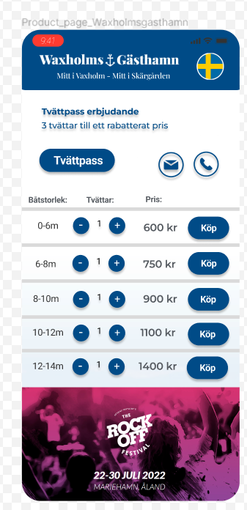

**Figure 2**

* **Book time slot Screen:** After user will select the boat washing sessions from the booking page he/she will redirect towards the book time slot screen from there user can see the available slots for book his/her boat for washing for that washing centre Please refer **Figure 3**

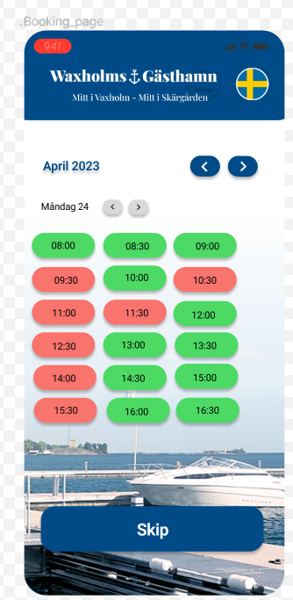.

**Figure 3**

* **Confirm booking:** once the user will select the available slots he/she click on the ‘ship’ button than he will redirect towards the booking confirmation page on which following details would be shown
* User name
* Boat length
* Selected slots (time & date)
* Amount to be paid
* Confirm booking CTA button

Clicking on the confirm booking CTA button will redirect the user towards the payment page for doing payment an then after the successful payment it will show the message to the user that payment is done and then QR code will be generated, and that QR code will be used by the wash centres to process for the boat washing. Refer **Figure 4** for the booking confirmation page. (**WE NEED TO UPDATE THE DESIGN AS MENTIONED)**

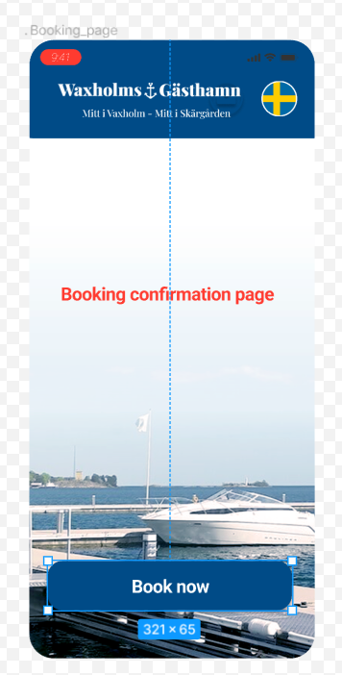

**Figure 4**

## Admin Panel Enhancements

In admin section we also need to update one new features for the booking process of the various boats from different washing centers which will be known as booking Management

* **Booking Management**: In the booking management admin will be able to see the booking details of any users and the details about the washing centers for the available booking slots and booked slots.
* **Wash center**: In wash center list we will add one more column for the booked slots and available slots for the particular wash center. Which admin can access , Refer the below **Figure 5** for the admin section over here we will add column for the showing booked and available slots for the was centers.

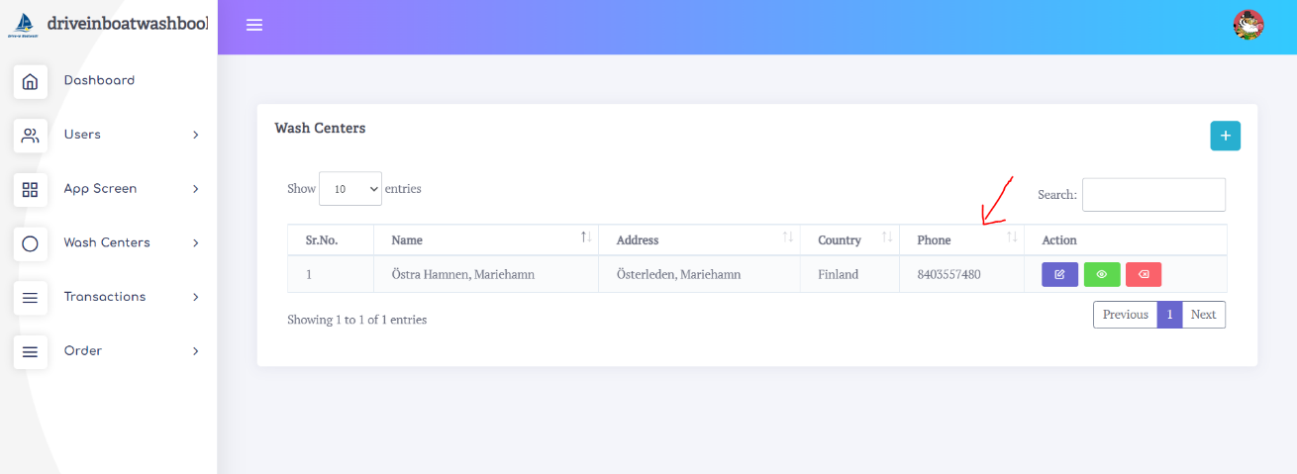

**Figure 5**

* **Changes to do in Add wash center:** when admin will add the wash center he will have two new features first for adding the date picker for choosing thedates and one for time picker for choosing the time. So by this way admin can add dates and time for the available slots refer the below **Figure 6** when we click on add button this form appears in this form we will add two more columns for date picker and time picker for a particular wash centers which will be reflect on the app when user will select any wash center for booking slots.

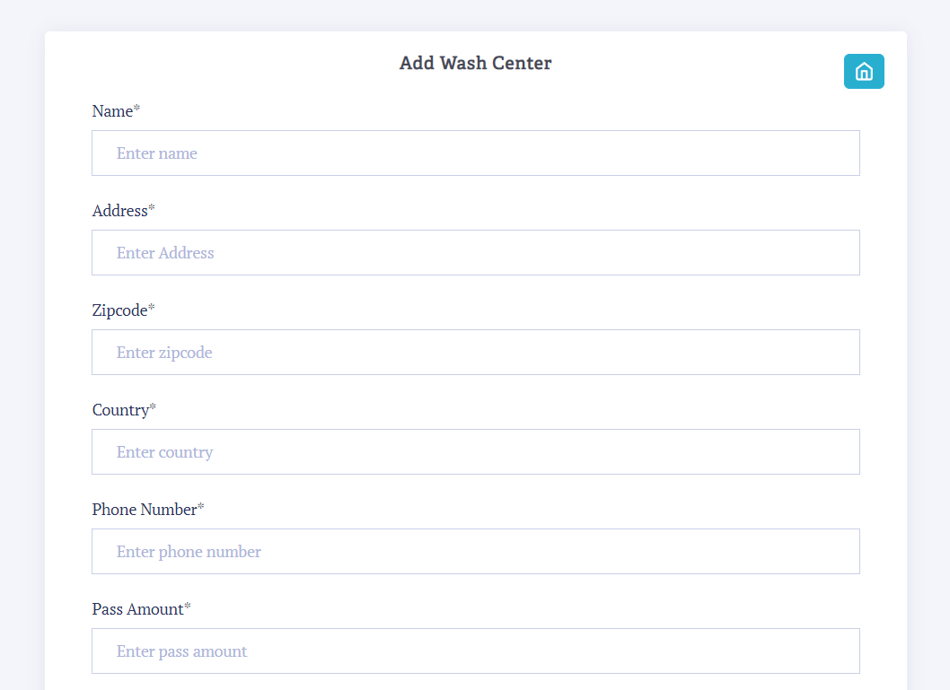

**Figure 6**

## Detailed Business requirements (Android)

| Req. No | **Requirement ID** | Business Requirement | Req. Type * | Priority ** | Originator *** | BR Traced to Business Requirement/ Use case ID |
| --- | --- | --- | --- | --- | --- | --- |
| 1 | BR001 | * **Development and functionality ( Android )** * Showing list of all the wash centres coming from admin end. * Selection of the wash centre * Boat wash booking screen UI designs in XML * Select boat length and number of times to wash the boat * Pay now redirection of the user to move on payment gateway to pay * Booking API integration * Booking confirmation page * QR code generation for the booked slots * Internal testing and fixes | F | 1 |  |  |

# 

## Detailed Business requirements (ios)

| Req. No | **Requirement ID** | Business Requirement | Req. Type * | Priority ** | Originator *** | BR Traced to Business Requirement/ Use case ID |
| --- | --- | --- | --- | --- | --- | --- |
| 1 | BR001 | * **Development and functionality ( ios )** * Showing list of all the wash centres coming from admin end. * Selection of the was centre * Boat wash booking screen UI designs * Select boat length and number of times to wash the boat * Pay now redirection of the user to move on payment gateway to pay * Booking API integration * Booking confirmation page * QR code generation for the booked slots * Internal testing and fixes | F | 1 |  |  |

## Detailed Business Requirement (Admin Panel)

| Req. No | **Requirement ID** | Business Requirement | Req. Type * | Priority ** | Originator *** | BR Traced to Business Requirement/ Use case ID |
| --- | --- | --- | --- | --- | --- | --- |
| 1 | BR001 | * **Development and functionality( Admin Panel booking management )** * API creation and integration for the booking to connect with the mobile app * **Add Wash centre (add/Edit available slots)** * Date picker feature * Time picker feature * Form submission * Updation in database as per these changes * **Wash Centre** * Add feature for showing booked slots and available slots * Updation in database as per these changes * Internal testing and fixes | F | 1 |  |  |

# Technical specifications

* Native app
* JAVA
* SWIFT
* Laravel

# References

Below is the location to get references from client communication

Client communication [(To be added by the person communicating with the client)](D:\\Project.Docs\\2020.11.17.e20.io\\2020.11.20.Shared.With.Client\\ATPL-20201117-e20.io\\Client.Discussions)

# Change Log

|  |  |
| --- | --- |
| Version Number | Changes Made |
| V1.0 | Initial baseline created on Feb 9th , 2022 |
| V1.1 | |  |  |  |  | | --- | --- | --- | --- | | Section No. | Changed By | Effective Date | Changes Effected | |  |  |  |  | |  |  |  |  | |  |  |  |  | |

# 